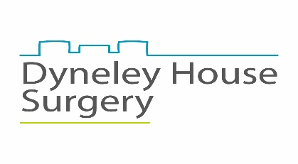
PATIENT PARTICIPATION GROUP
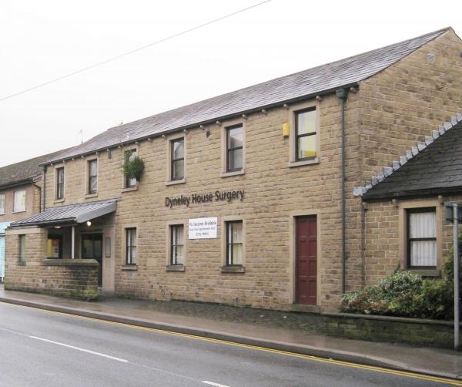

ANNUAL REPORT 2021

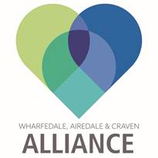

PATIENT PARTICIPATION GROUP ANNUAL REPORT 2021

This report highlights some of the activities and issues which have taken place during the past couple of years. This is because as everyone is only too aware the Covid 19 pandemic changed everyone’s lives and the world we knew from the first few months of 2020 and continues to be the single biggest challenge we still face in 2021. Because of this and the restrictions which are vitally necessary we did not hold an AGM in 2020 and many activities throughout 2020 were cancelled, modified or moved into the new “normal” of online or virtual means.
The Patient Participation Group at Dyneley House Surgery was formed in December 2010 and has continued to be involved in a range of activities in support of the services provided by the Surgery for the benefit of fellow patients over the years.
The key aims of the Group continue to be: -
- To act as a communication channel between the patients and the Surgery and vice versa.
- To give a patient’s contribution to the development of new services or extension to present services or treatments.
- To help fellow patients to take more responsibility for their own health and wellbeing’
- To enable patients to give their views and comments through surveys and questionnaires on their experiences of the Surgery for them to be reviewed by the Surgery and where possible consider changes.
The Committee of the Group continued to meet both on a formal basis and on a number of informal occasions during 2019 These meetings were attended and supported by Surgery staff for which the Group continues to be grateful.
Following the impact of the covid virus meetings were not held for several months during early 2020 although email and telephone conversations were held. Later in the year like many organisations both statutory and voluntary, meetings have and are taking place via a zoom platform
The following patients of the Surgery have continued to be a member of the PPG Committee or have joined during the past year –
Barry Rogers
Mary Jenkins
Clare Shephard
Pamela Reader
Brian Harrison
Judith Benjamin
Hazel Bulcock
Mike Palin
Peter Bell
Olukayode Dada
Sally Harrison
Kathleen Sutton
Heidi Edmondson
Elizabeth Benjamin

The past year has been a challenging one for all PPG’s and Practices including Dyneley not only with regard to Coronavirus which due to social distancing and ‘stay at home messages’ the way access to services was changed for many patients and staff.Whilst the Practice remained open where it was necessary much more use of phone contact and digital facilities eg e- consult helped to limit possible transmission of the virus.A survey was undertaken by Practices within WACA to look at how these arrangements had affected patients views on access to GP services.
In addition the past year saw many changes taking place in respect of commissioning,
the two Bradford CCGs and the Airedale, Wharfedale and Craven CCG merged into one Governing Body,
The Wharfedale Airedale and Craven Alliance (WACA) of which Dyneley is a key partner continued to develop as a Primary Care Network and its Patient Network Forum.
In the past few weeks the Government has published its White paper on the planned rollout of Integrated Care with the intention of the many elements of Health, Social Care and local government and public health working together.

During 2019
During 2019 the PPG was able to continue to help and support the Practice as it had for a number of years , this included helping to support the Support Groups such as the Stroke group which developed links with the Aphasia Skipton Group, Sporting Memories and the Osteoporosis Group.
Members also took thev opportunity to help in the training of new doctors by acting as “patients “ at one of the pra tical examination sessions monitored by Dr Pettit.
Flu clnics were again supported by members and this was much appreciated by the Practice staff
As in previous years a Patient Survey was carried out in the Surgery, this was discussed in one of the Committee meetings in addition to the results of the National GP survey relating to Dyneley. The results of the local survey can be accessed on the PPG page of the Practice Web site along with previous surveys and are attached to this years AGM papers.
Self Care Week was once again held in November and a range of activities and information sessions were held and members of the PPG attended and psrticipated in the sessions.

During 2020
As already noted 2020 was a year no one expected, throughout the year and into 2021 the impact of the coronavirus affected every aspect of our lives. Several Support groups have taken on the task and sometimes the challenge ? of the new normal of virtual meetings using zoom and team platforms.
One of the key topics which the PPG has looked at has been the development of a Virtual Reference Group. The aim of developing this group is to develop a wider base of patient feed back on specific issues that the Practice would welcome patient’s views on. It is hoped to provide further details on this matter at the AGM and in the coming weeks.
This year the Practice responded as expected in a highly professional and expert manner to deliver the flu programme closely followed by the covid vaccination. This necessitated very careful planning , close observance of social distancing by use of volunteer marshalls. This later programme was a great team effort involving current staff, return of staff to carry out vaccinations and volunteers.
This year the Self Care week was held in November virtually and one of the highlights of the week was a zoom session on Womens Health which was delivered in Punjabi for patients of the ethnic population and was very well received,
As mentioned earlier there are many changes occurring on the Health and Social Care landscape and many voluntary organisations including PPGs are looking at how they can contribute to ensure that patient and public involvement are a taken into account as these plans are taken forward in the coming weeks and months.

This report cannot be finished without thanking all staff at the Practice who have continued to help and support the PPG at a very stressful and challenging time. In particular Antony, Joanna and Emma. We look forward to working with Amanda who has joined the Practice as a Social Prescriber in recent months.
The opportunity is also taken to pay tribute to two GP Partners who have retired, Dr Bruce Woodhouse a much loved and respected GP,who also played a key role at the CCG and Dr Andy Sumnall who not only carried out his role as a GP but also carried out the function of Registered person in respect of the Care Quality Commission and ensured compliance with the current regulations.
In conclusion thanks to all members for their ongoing support and commitment to the work of the PPG.

Barry Rogers
Dyneley House PPG
February 2021

.

